Andrew Mason (aemason@alaska.edu)
Keith Schneider (1900Geek@gmail.com)
Jacob Dempsey (Jacob@JacobsChaos.com)

Final Project:

This is the documentation of the development process and code implementation of our project Saving Face.

Overview of Requirements and Features:
More requirements would be nice
Our project requires that the user has the Intel Creative Camera, all of the functionality within our project requires the camera. Saving Face features 3D model reconstruction and comparison of a persons face. Taking a users face and mapping retrieved depth values to a 3D model based off of the yaw, pitch, and roll of the face centering the tip of the users nose to the origin of the 3D coordinate model.

Complete Feature List:

Note: ID does not represent order.
ID | Story Name | Description | NUTS
1 | Fixed Point Orientation | Find X Y Z of at least three fixed points; Or 1 and Yaw Pitch and Roll | 2
2 | Transform Module | A Module that applies the Transform to bring the points into a common plane | 6
3 | Build Model Module | A Module that takes the transformed data and makes a model representation | 5
4 | Compare Module | A Module that takes a stream and compares it to a list of Models and returns a ranking | 5
5 | Load Module | Load a model from a file | 2
6 | Save Module | Saves a model to a file | 2
7 | Debug Terminal | Displays Helpful Information | 2
8 | Save Depth and Color Video | A Module that saves video for later re-use | 4
9 | Display Streams | A Module that displays Depth and Color Streams | 1
10 | User Information Input | A GUI Interface for inputting model Information | 3
11 | Save Image Data | A Module To Save a User Photo for Later Display | 2
12 | Load Color/Depth Video | A Module To Load Video Playback for Algorithm Refinement and Debugging | 4
13 | Load user Image | A Module to Load and display a user image | 2
14 | Activity: Model Collection | Collect Model Data To Test | 3

Development Estimates and Actual Progress:

Our estimates were pretty close to spot on for this project, at the end some were altered by one or two points. Our burn up chart accurately represents the teams completion of nuts during this process. Our project had iterations that were not truly defined by iterations of equal amounts of work time so it is hard to encapsulate the iterations in the chart. Our first iteration may have had 10 – 15 actual hours of work, where as our last iteration easily had over 80 hours of work. From the time that the project started to now we noticed an exponential increase of hours put in vs. time passed. The burn up chart increases as we noticed we had to revisit a previous user story, and we switched from a debug terminal to a GUI. There was also a function that was not implemented in the PC SDK that we were relying on. In realization that this method was not implemented we had to create our own function to convert color coordinates to depth coordinates.
Our estimates mid semester showed us that we were not going to finish the project on time. However thanks to complete devotion at this critical point we tripled the amount of work being done. The estimates taken several weeks after showed us that we could finish the project on time.
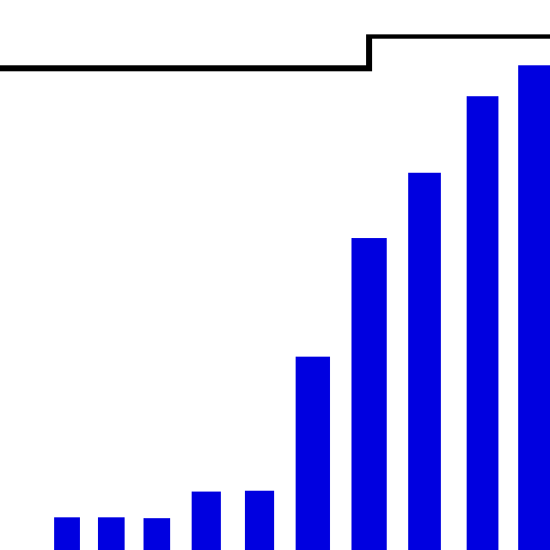
Description of the Design:
- TODO Description of the design, algorithms
- Note: uml would look great here

Description of the Finished Product:
This should be more wordy with the specifics of our completed project.
Saving Face is an application designed to build and compare 3D models using the Intel Creative Camera. Saving Face takes a depth image of a users face and builds a 3D model of it, then saves the model into the database. On a face comparison it will iterate through all of the database models comparing vertices with each other to determine a match.

Description of Tests:
Add anything you want here, there was more to testing than just this
We used an automated testing system for the development process, we did do testing first but sometimes we did testing after. The automated testing system was an excellent way to track bugs and fix them. Testing first gave us more insight on how to avoid bugs in a given function. Testing first may feign a delay of progress but it saved so much time in the long run. We have multiple tests for functions and did a good job at determining a function was working based on an correct output with given inputs.

Description of the Process:
At the beginning of development we did good at staying true to the agile method. We created user stories and had client meetings that would help us get started. Later on in the development process we deviated from the agile methodology. When we realized we had to play a bit of catch up, we started tackling user stories independently without acceptance tests. With time constraint at our backs we had to make the biggest jump we could in a short amount of time.

Who Worked on What:
This may need to be more of a task completion rather than titles.
Keith Schneider:
Project analyst, project lead, concept designer, lead programmer and
lead tester.

Andrew Mason:
Assistant programmer, assistant tester, and assistant designer.

Jacob Dempsey:
Assistant programmer and lead GUI designer.

Overall Experience:
I think each of us should throw some of our input into this section of the report.
One of the biggest challenges was creating a constant schedule for our project. While other classes interfered we found that our hours of work varied week by week. Creating a definitive schedule of what needed to be done and how many hours should be done in an iteration for each team member would have helped a lot. We learned many new programming techniques and also a new and wonderful SDK. This was a very large project and in hind sight we believe that more team meetings to get the team organized would have been be better. Allowing more direction for individual tasks and also adding a better understanding of the code implementation.

